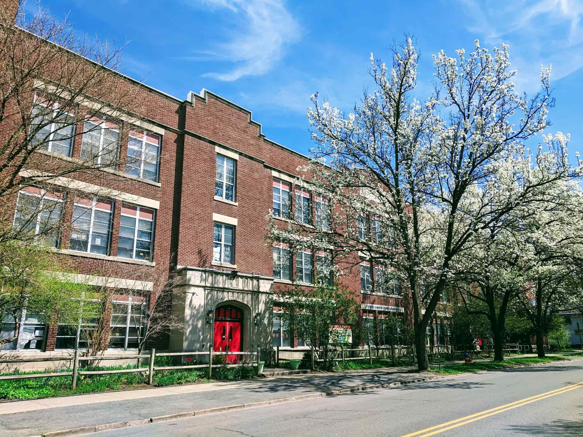

MINIMUM CAPACITY :-

The Minumum intake capacity

of students is between 4000-5200

children

LIBRARY :-

The Libarary is Available.

CANTEEN:-

The Canteen Facility is Available.

BOARDING :-

No availablility of boarding.

SPORTS :-

There are different categories

sports available.

Girls Volleyball

Boys Volleyball

Football

|  |  |  |
| --- | --- | --- |
| BEVERLY J MARTIN SCHOOL ITHACA - SCHOOL |  |  |
|  |  |  |
| School Detail :- Beverly J Martin Elementary School is a public school located in Ithaca, NY, which is in a small city setting. The student population of Beverly J Martin Elementary School is 268 and the school serves PK-5. At Beverly J Martin Elementary School, 22% of students scored at or above the proficient level for math, and 32% scored at or above that level for reading. Beverly J Martin Elementary School is a public school located in Ithaca, NY, which is in a small city setting. The student population of Beverly J Martin Elementary School is 268 and the school serves PK-5. At Beverly J Martin Elementary School, 22% of students scored at or above the proficient level for math, and 32% scored. |  |